



CHAI Seminar Series

# **DATE:** Monday, November 7, 2022, 12:00-1:00 PM

**SPEAKER:** Barbara Plank, PhD

# Professor of AI and Computational Linguistics, LMU Munich

**TITLE:**Is Human Label Variation Really So Bad for AI?

**REGISTRATION LINK:** <https://rit.zoom.us/webinar/register/WN_B3Il4wf1T1m9K1IwGCxRDg>

**ABSTRACT:** Human variation in labeling is typically considered noise. Annotation projects in computer vision and natural language processing typically aim at minimizing human label variation, in order to maximize data quality and in turn optimize and maximize machine learning metrics. However, is human variation in labeling noise, or can we turn such information into signal for machine learning? In this talk, I will first illustrate the problem and then discuss approaches to tackle this fundamental issue.

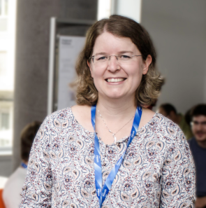**BIO:**  **Barbara Plank** is Chair (Full Professor) of AI and Computational Linguistics at LMU Munich, where she leads a research lab in Natural Language Processing (NLP) at the Center for Information and Language Processing (CIS). She is also a professor (part-time) at the Computer Science Department of the IT University of Copenhagen, where she co-leads the NLP North research unit. She holds a BSc and MSc in Computer Science and received her PhD in Computational Linguistics in 2011.

[**https://www.rit.edu/chai/**](http://www.rit.edu/chai/)